**OOP LAB – Assignment 11**

**Task 01:**

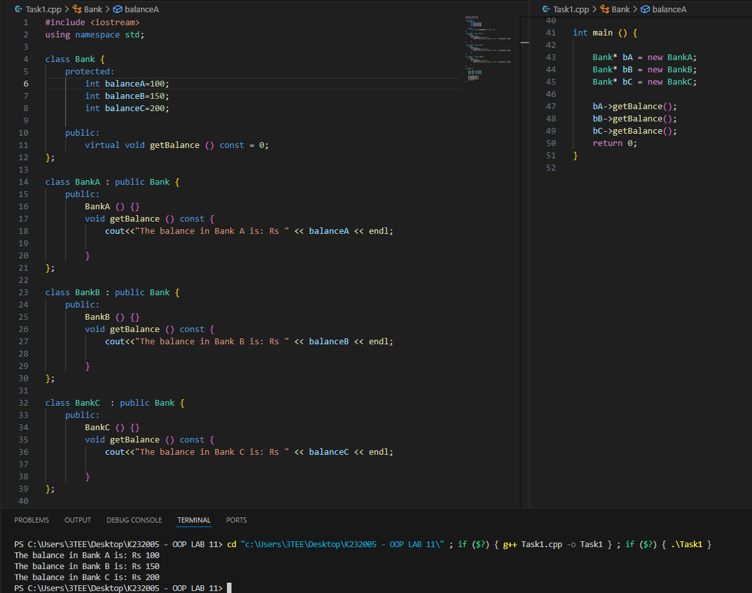

**Task 02:**

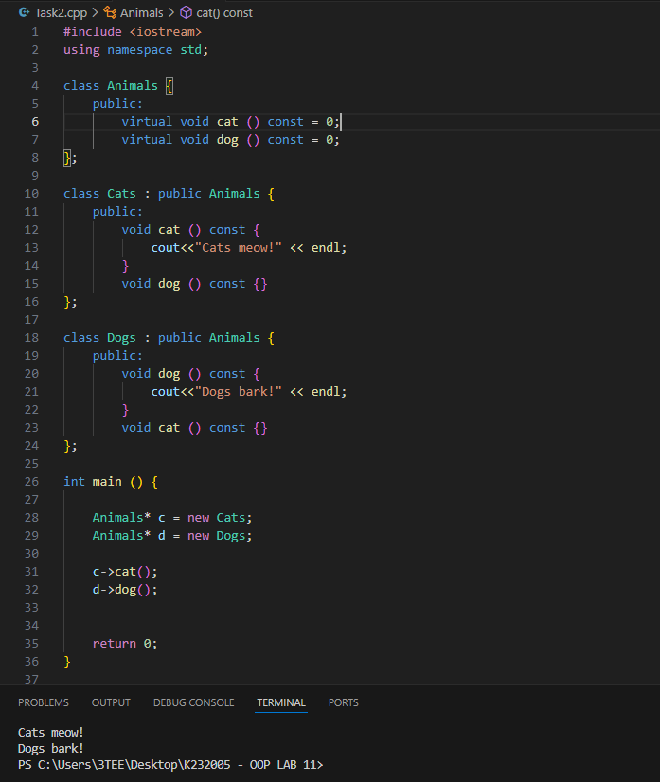

**Task 03: Using Pointer**

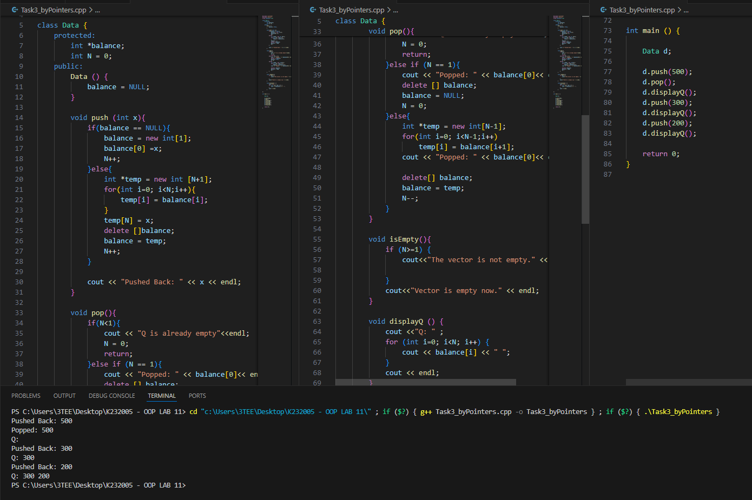

**Task 03: Using Vector**

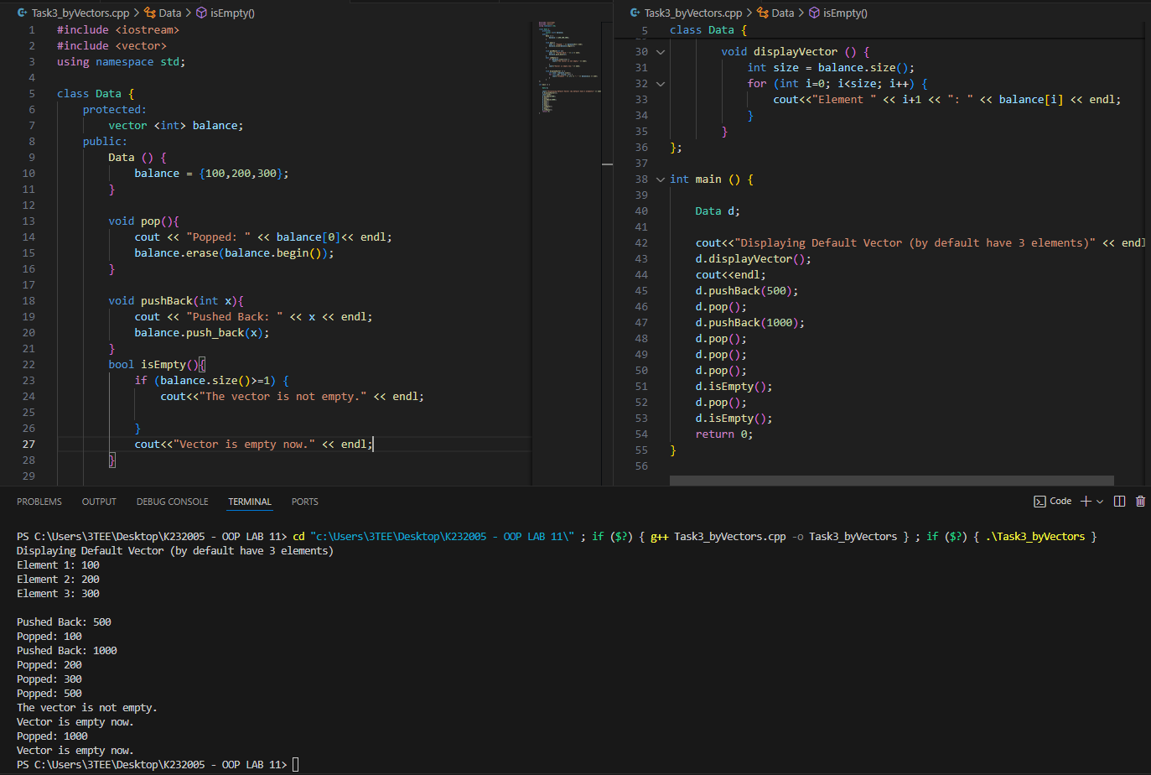

**Sir, bonus weightage for solving the question by two approaches please :D**

**Task 04:**

